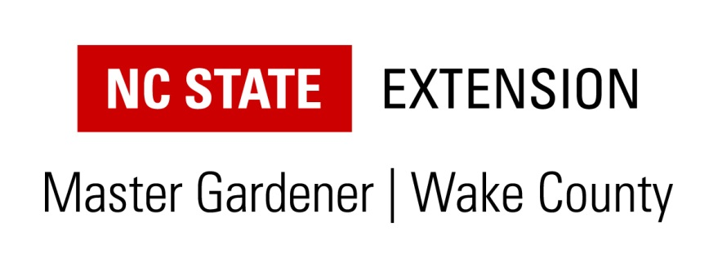
Thanks for your interest in our Extension Master Gardener Volunteer program!
We will be starting a new training session in September 2020. In April 2020 we will be contacting all those who have expressed interest and invite them to submit an application and to attend an informational session. This session will be to provide an overview and answer any questions you may have about our program.
If you are interested in being contacted when we begin planning for our next class, you may send us an email and please include your full name, mailing address and phone number, along with your email address. This information will be held on file. If you prefer to fill out the application form and submit it now, we will also hold that on file until we prepare for the next class. Send it to the address below in care of my name. https://wake.ces.ncsu.edu/wp-content/uploads/2020/01/2020-current-mgv_application-1.pdf?fwd=no
The training will begin in September 2020 and run through February 2021, with classes being held each Thursday morning from 9-12:30 here in our office. The Extension Gardener Handbook can be found at https://content.ces.ncsu.edu/extension-gardener-handbook . Once a trainee becomes an Extension Master Gardener, they are expected to volunteer at least 40 hours per year. There are a number of volunteer programs including community gardens, youth groups, farmers market clinics, demonstration gardens, and phone duty. We currently have 160 Extension Master Gardeners in Wake County - a number have been with the program for 10 to 20 years! The approximate cost of the class is $160 which includes a handbook and all materials. We do have a limited number of openings for the training, primarily because we need to limit the class size to 35 people.
Thanks again for your interest in becoming an Extension Master Gardener. I hope we can make use of your interest in our program!
Jeana Myers
Horticulture Agent in Wake County
4001 Carya Drive
Raleigh, NC 27610
919-250-1113

Extension Master Gardener Volunteer – Questions?
Phone contact: 919-250-1084
Email: mgardener@wakegov.com

